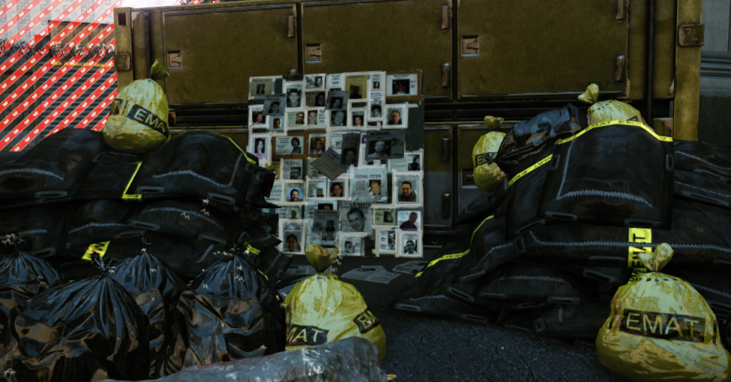

Level Design Document – Single Player Crysis 2 Level
Designer | Katie Wood
Level Name | Indiscriminate
Due Date | May 13, 2015
Document Revisions
Date | Description | Initials
4/13/15 | Completed Pg.1 and Development Schedule Requirements | KW
4/15/15 | Completed Overview Map and Area #’s maps, Created a Table of Figures, Created rough draft of Level Progression Chart | KW
4/16/15 | Revised Overview Map, Legend, and Level Progression Chart, Completed the Objectives section, Summary section, Level Progression Steps, Area 1 Description and Requirements, Area 2 Description and Requirements, Detailed Path Maps and Descriptions for Areas 1 and 2, General Thematic Elements, Area 1 and Area 2 Aesthetics Images, Perspective Drawings, Lighting Images, and Gameplay References. | KW
4/17/15 | Added a few Aesthetics Details, Added Real World Area References, and Completed Initial LDD | KW
5/13/2015 | Updated images and Area 2 description to include the new enemy addition | KW

Contents
1. Overview 4
Map 4
Objectives 5
Summary 5
Location 5
Backstory 5
Hook(s) 5
WOW Moment(s) 5
Gameplay Highlights 6
Development Schedule 6
2. Gameplay 9
Level Progression 9
Area 1 – “Encounter Area 1” 10
Detailed Area Map 10
Area Description 10
Requirements 11
Detailed Pathing Maps 11
Area 2 – “Encounter Area 2” 13
Detailed Area Map 13
Area Description 13
Requirements 13
Detailed Pathing Maps 14
3. Aesthetics 15
General Thematic Elements 15
Area 1 19
Special Thematic Elements 19
Lighting/Mood 21
Visual References 22
Area 2 25
Special Thematic Elements 25
Lighting/Mood 26
Visual References 29
Gameplay References 30

Figures
Figure 1: Overview Map and Legend 4
Figure 2: Detailed chart of level's progression 9
Figure 3: Encounter Area 1 Overview Map and Legend 10
Figure 4: Area 1, "Run and Gun" Critical Path 11
Figure 5: Area 1, "Stealth" Critical Path 12
Figure 6: Encounter Area 2 Overview Map and Legend 13
Figure 7: Area 2, "Run and Gun" Critical Path 14
Figure 8: Area 2, "Stealth" Critical Path 14
Figure 9: Non-Crysis game examples of Quarantine Zones/Infected 15
Figure 10: Examples of Crysis Environmental Storytelling/Tone/Thematic Inspiration 16
Figure 11: Clutter Examples/Environmental Story Details 17
Figure 12: Building References, EMAT Tent Interior/Exterior 17
Figure 13: Surrounding Architecture Examples 18
Figure 14: Area 1 E1 and E2 EMAT decontamination tents 19
Figure 15: Perspective of Area 1 Scripted WOW Moment 20
Figure 16: Real World Example of Scripted Civilian/CELL WOW Moment 20
Figure 17: Examples of Exterior Lighting, Contrast, and Shadowing 21
Figure 18: Examples of E1 and E2 Tent Interior Lighting 21
Figure 19: Example of Homeless Communities, Personal Items 22
Figure 20: Example of "Indiscriminate's" Exterior Environment, Primarily found in Area 1 23
Figure 21: Real World Examples of Area 1 E1 and E2 tents 24
Figure 22: Example of Area 2’s Fencing/Barrier 25
Figure 23: Example of unique Area 2 E3 Tent Mesh 25
Figure 24: Perspective of Area 2 Scripted Enemy Encounters 25
Figure 25: Overhead, artificial lights 26
Figure 26: Blue, eerie tone of light 27
Figure 27: E3 Interior Tent Window Lighting 28
Figure 28: Examples of Area 2's pre-existing Crysis Visual References 29
Figure 29: Real World Example of Interior E3 decontamination tent 30

Overview

Map
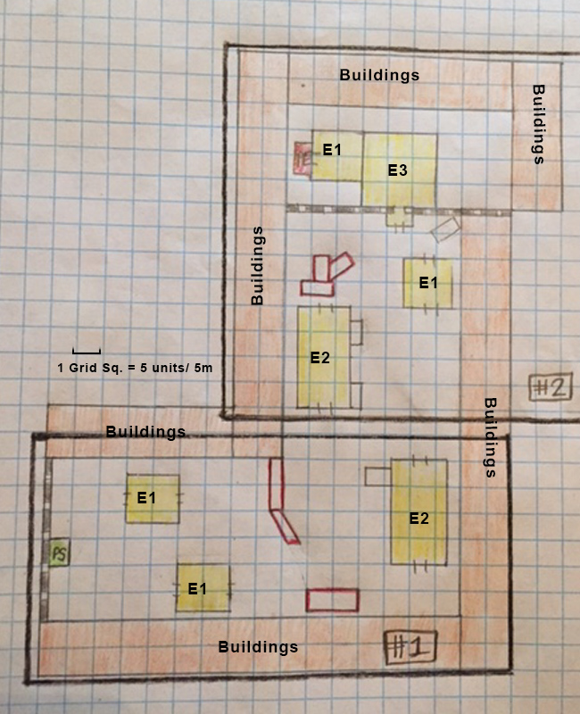
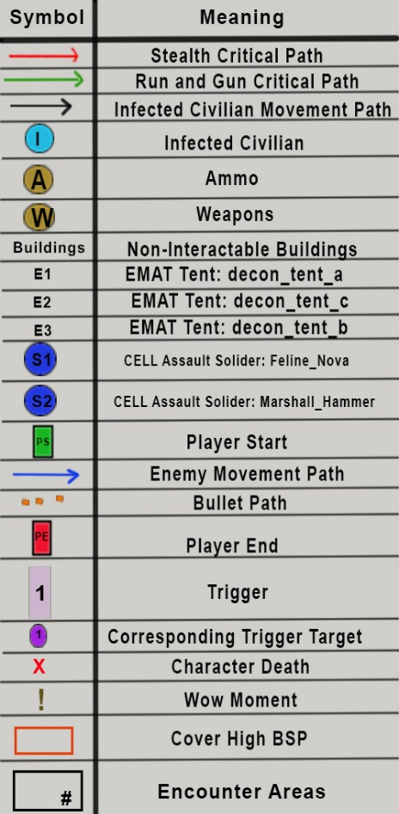

Figure 1: Overview Map and Legend

Objectives
The “Indiscriminate” level contains a singular, core objective for the player to undertake and complete. This solitary goal allows the designer to guide the player through other means, including lighting, environmental storytelling, enemy pathing, etc. However, the objective message does provide helpful information regarding the mission’s purpose and surrounding narrative.
Objective 1:
- “Infiltrate the main C.E.L.L EMAT decontamination tent.”

Summary
“Indiscriminate” is a Crysis 2: Maximum Edition single player level occurring within a post-apocalyptic New York City. At the outset of the level, players navigate through an EMAT decontamination settlement in search of the main facility. Throughout the course of “Indiscriminate,” there exist two central playstyle choices, including the cautious “Stealth” strategy or the aggressive “Run and Gun” strategy. The player employs these tactical options when encountering either the incorporated “C.E.L.L. Grunt: Feline_Nova” or the “C.E.L.L. Grunt: Marshall_Hammer” enemy types. Upon reaching the core objective point, the “Indiscriminate” level concludes.

Location
“Indiscriminate” takes place within the confines of the Crysis 2: Maximum Edition world. Cephs scour New York City in hopes of infecting and destroying the human race. C.E.L.L. soldiers, contracted by the US Department of Defense, attempt to fight the invading aliens, but to little success. Alcatraz, successor to Prophet, must utilize the heightened Nano suit and assist in the fight for humanity.

With this premise previously established, the “Indiscriminate” sequence occurs outside of the main game’s progression. In this separate, standalone mission, Alcatraz must shut down a military operated “extermination” facility. The level opens with Alcatraz standing just inside C.E.L.L barrier, placed to deter passerby. The sun is beginning to set and the time is around 7:00pm. Alcatraz emerges into the quarantine area and encounters various established homeless communities. Fires, mattresses, and food litter the open areas. EMAT tents occupy the largest amount of space and provide cover for the player. Alcatraz eventually reaches the inner stronghold of the base. Past a large gate or wall, the player spies militarized EMAT decontamination tents. Bodies, blood, and debris characterize the area, alluding to the CELL’s unmerciful practices.

Backstory
The recent outbreak of the Ceph manifested virus, “Manhattan” has caused panic amongst the citizens of New York City. In an effort to contain the outbreak, C.E.L.L. soldiers, contracted by the US government, begin moving civilians to quarantined areas. In these areas, the humans operate in homeless-style communities, sleeping on mattresses, distributing food, etc. However, the C.E.L.L. separate the infected individuals, housing them in central EMAT decontamination tents. Once there, these sick civilians are subsequently evaluated and treated.

However, due to the rise in the number of infected, lack of resources, and increasing disorder, the C.E.L.L. soldiers decide to simply gather the remaining civilians, infected or not, and exterminate them. This extreme conclusion results in a persecution-fueled genocide in which any non-solider dies. Alcatraz hears word of these disgusting acts and decides to intervene. However, inside the compound, Alcatraz discovers that he may be too late. The settlement contains copious amounts of blood, drag marks, and graffiti warnings. These various minor clutter details and resulting scene composition serve to communicate “Indiscriminate’s” story to the player and illicit an emotional attachment.

Hook(s)

WOW Moment(s)

The “Indiscriminate” level features a powerful WOW Moment in Encounter Area 1 of the Overview Map (See Figure 1). When the player enters a designated trigger, an infected civilian runs along the corresponding movement path. As the player enters a nearby second trigger, a C.E.L.L. solider awakens and fires at the unarmed civilian. Upon the civilian’s death, the murderous solider moves to observe the corpse.
This sequence conveys the brutality and cruelty of the C.E.L.L. soldiers in this settlement and consequently warns the player of upcoming battles.

Gameplay Highlights

Gameplay highlights in the “Indiscriminate” level include:
- Combat against several C.E.L.L. soldiers of two enemy types
- Employable stealth tactics throughout the level
- Alternate pathing based on player preference

Development Schedule

Milestone | Due Date | Success Requirements | Failure Requirements
Initial LDD | 4/17/15 | - All encounters are designed and sketched (top-down/side sketch and perspective sketch for each encounter)  - Visual theme is decided  - Lighting theme is decided  - Level location is decided  - Player path, progression, and objectives are decided  - Adequate reference materials (images, sounds) have been collected  - Document can be understood by any Designer (to the extent that they could make the level themselves)  - Document is free from spelling errors, punctuation errors, and grammatical errors | - Grammar Errors and Misspellings  - Inadequate number of reference images  - Difficult to read and understand  - Undefined visual theme  - Undefined lighting theme  - Undefined level location  - Poorly illustrated overview map and legend
Whitebox | 4/24/15 | - All issues from previous milestone are fixed before proceeding with this milestone  - Critical path must exist from start (player spawn point) to finish (end goal location/trigger)  - Player must be able to spawn from the correct location at level start  - Player must be able to navigate the world without issue (no world holes along critical path)  - If player must pass through a blocked area to progress along the critical path, the blocked area must exist (either in Solid or Model form) and must be able to be unblocked (probably through scripting) to allow progression  - Critical path must be lit with temporary lighting, although the temporary lighting must indicate the lighting’s final form (no flat ambient lighting, use light entities)  - Level Solids and Models must use either the default Checkerboard material, or a flat grey material  - Level must be scaled appropriately to both player size and to the intended gameplay  - Level must be detailed enough (with Solids or Models) to indicate locations and intended aesthetics  - Wherever possible, use Solids; if part of the level needs to be sized to support specific Models, build Solids around the Models then remove the Models for this milestone  - Level contains no AI (friendly or enemy), player should be the only active entity in the level | - Missing representative architecture  - Inadequate sizing and scaling  - Missing critical path  - Missing or broken player spawn  - Block-able and unblock-able areas broken or not functional  - Temporary lighting unimplemented  - No default material  - Lack of level detailing through representative BSP  - AI incorporated
Gameplay Initial Testing | 4/29/15 | - Initial gameplay elements incorporated, including weapons, pickups, enemy paths, and scripted events  - Player spawn and enemy spawns properly placed  - Architecture provides enjoyable experience | - Missing gameplay elements  - Incorrectly placed player spawn and enemy spawns  - Architecture provides unenjoyable gameplay experience
Gameplay | 5/1/15 | - All issues from previous milestone are fixed before proceeding with this milestone  - All required gameplay exists in the level  - Gameplay has been tested, iterated, and refined  - No gameplay bugs exist (player cannot get stuck, player cannot see/fall/climb out of the world, scripted gameplay sequences execute flawlessly)  - Level is still at Whitebox visuals  - Level layout has been altered to allow any gameplay modifications deemed necessary during implementation (alterations must adhere to the Whitebox rules)  - All triggered and/or scripted events directly related to player’s critical path, including AI spawning and control, must exist without bugs  - If gameplay requires sound and/or particle use (including VO or radio), these must exist without bugs  - Objectives must be implemented and working without issue  - Tactical Scans (if needed) must be implemented and working without issue | - Missing gameplay elements  - Incorrectly placed player spawns and enemy spawns  - Architecture provides unenjoyable gameplay experience  - Untested gameplay  - Gameplay bugs exist  - Whitebox visuals exist  - Tactical Scans unimplemented  - Objectives are broken or missing  - Missing necessary sound or particles  - Triggered or scripted events including AI spawning and control have bugs
Gameplay Revision/  Pre-Aesthetics Testing | 5/6/15 | - Revised gameplay elements stemming from gameplay milestone feedback  - Initial aesthetic elements incorporated including textures, lighting, clutter and static meshes.  - Environmental Storytelling through clutter and scene composition implemented | - Unrevised gameplay elements  - Missing aesthetic elements  - Emotional Storytelling fails to illicit proper player response.
Aesthetics | 5/8/15 | - All issues from previous milestone are fixed before proceeding with this milestone  - All Solids have final textures (no default Checkerboard visible along the player’s path)  - No visual errors exist (misaligned textures, floating models, world holes)  - No audio errors exist (missing sounds, incorrect volume)  - Level is lit appropriate to intended design, and is of a high visual quality  - Environmental authenticity is maintained throughout the level (nothing breaks immersion) | - Missing aesthetic elements  - Inappropriate placements of lighting, textures, and meshes.  - Visual errors exist  - Audio errors exist  - Environmental authenticity is not maintained throughout the level  - Emotional storytelling fails to illicit proper player response
Final Aesthetics/  Final Gameplay Testing | 5/11/15 | - Final gameplay placement fully included  - Final aesthetic elements fully included  - Enjoyable visual and gameplay experience  - Reasonable size and scale | - Incomplete incorporation of gameplay and aesthetic elements  - Too large or too small in scale  - Highly exploitable or unenjoyable areas
RTM | 5/13/15 | - All issues from previous milestone are fixed before proceeding with this milestone  - No gameplay errors exist  - No scripting errors exist  - No visual errors exist  - No audio errors exist  - Level can be completed  - Level can be distributed to other players (with appropriate details about prerequisites and installation)  - LDD is complete (updated with any changes made during level development) | - Gameplay errors exist  - Visual errors exist  - Audio errors exist  - Level cannot be completed  - Level cannot be distributed to other players  - LDD has not been updated or revised to final quality  - Highly exploitable or unenjoyable areas  - Ineffective environmental storytelling

Gameplay

Level Progression
- Initially, the player begins the “Indiscriminate” level immediately inside of a large C.E.L.L. barrier. This portion of the level is a city street or parking area converted into an EMAT decontamination facility. However, the player discovers that the various homeless-style communities are abandoned and empty.
- The player progresses through this area by either walking through the decontamination tents or around the decontamination tents. There are no combat encounters for the first 15 seconds of exploration.
- When the player reaches the first and second triggers in Area 1, a scripted event depicts a C.E.L.L grunt attacking an innocent civilian. Upon the civilian’s death, the soldier walks to and pauses at the corpse (WOW Moment).
- A second C.E.L.L. soldier also activates and begins patrolling within a nearby EMAT tent. The player employs either the “Stealth” or “Run and Gun” strategy to deal with the two foes.
- As the player enters the second encounter area, they discover a new SCAR weapon leaning against an EMAT tent. The player may equip the item if desired.
- After a minute and thirty seconds of gameplay, the player enters the third trigger, consequently activating two C.E.L.L. soldiers. One of these soldiers is a new enemy type than those previously encountered.
- When the player draws closer to these two C.E.L.L. soldiers, a fourth and final trigger activates the last C.E.L.L. soldier, propelling him out of the EMAT tent. This soldier initially resides within the confines of the main EMAT facility. The player employs either the “Stealth” or “Run and Gun” strategy to deal with the three foes.
- Once the player has dealt with the enemies via their preferred tactical option, they may complete their solitary objective. To do so, the player must proceed into the smaller, connecting decontamination tent.
- When the player enters this smaller tent, the level concludes, implying the player entered through the nearby door.

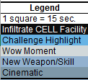

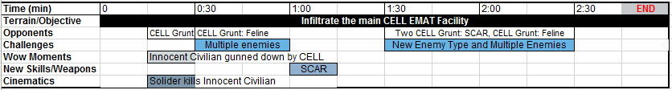
Figure 2: Detailed chart of level's progression

Area 1 – “Encounter Area 1”

Detailed Area Map
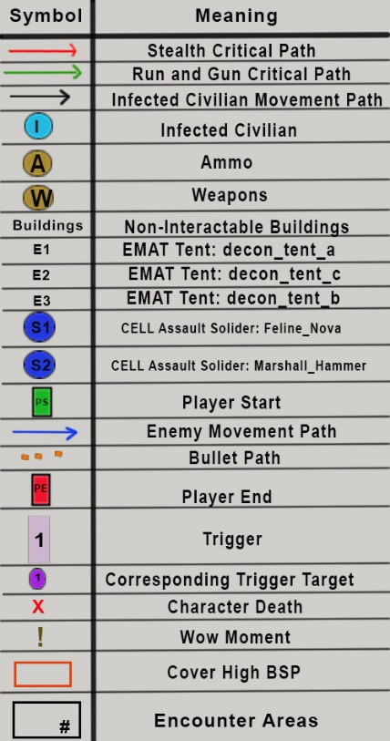
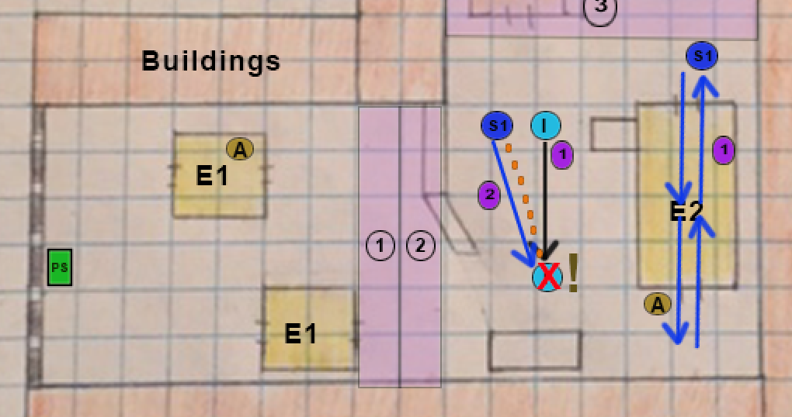
Figure 3: Encounter Area 1 Overview Map and Legend

Area Description
- The player spawns immediately inside of a closed gate or C.E.L.L. barrier. Initially, the player does not encounter or engage in any combat. Instead, the player may explore the environment, whether that be inside of the EMAT tents or around the EMAT tents. The scene composition of these sections provides environmental narrative, informing the player of the mission’s context.
- Once the player enters trigger 1, indicated by Figure 3, a scripted cinematic event occurs. The player witnesses a civilian fleeing from an unknown and unseen individual. As the player moves forward, the second trigger activates a C.E.L.L Solider. The awakened soldier proceeds to shoot and kill the escaping civilian. Subsequently, the Feline wielding soldier approaches and inspects his victim. The player may duck behind nearby cover to remain hidden from this C.E.L.L. soldier. (WOW Moment)
- Meanwhile, trigger 1 also activates a second Feline wielding soldier located within the section’s farthest E2 tent. While patrolling, the soldier briefly emerges from either end of the decontamination tent. This action allows the player an opportunity to spot the second C.E.L.L. and react accordingly.
- The player’s Nano suit updates the player’s tactical options for the area.
- Regardless of the player’s preferred tactical option, the player proceeds through the area and enters Area 2.

Requirements
- The player begins with a standard pistol.
- Objective text: “Infiltrate the main C.E.L.L EMAT decontamination tent.”

Detailed Pathing Maps

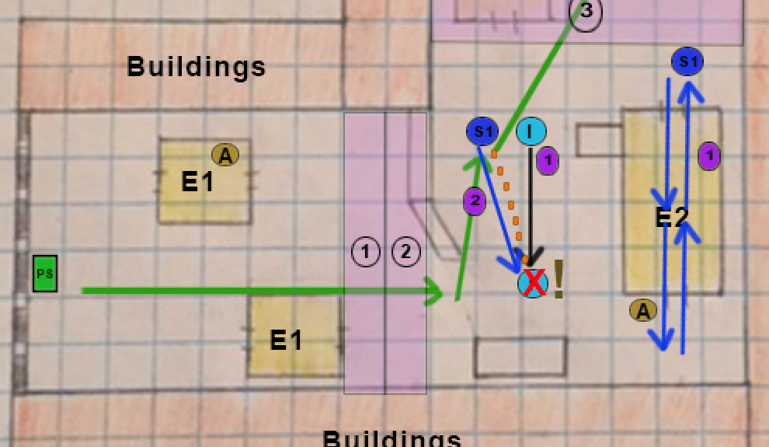

Figure 4: Area 1, "Run and Gun" Critical Path

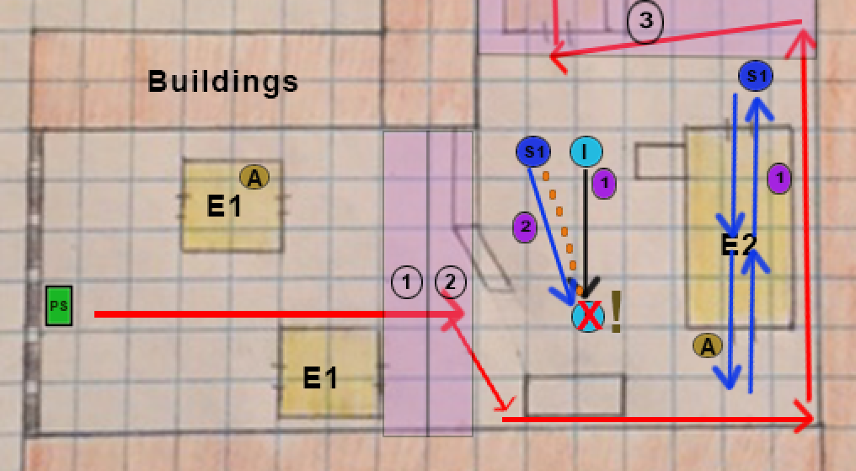
Figure 5: Area 1, "Stealth" Critical Path

Path Descriptions
- Figure 4 details the player’s critical or optimal path when utilizing the “Run and Gun” tactic. In this depiction, the player charges forward, confronts the first C.E.L.L. soldier and continues charging into the next section.

- Figure 5 details the player’s critical or optimal path when utilizing the “Stealth” tactic. In this depiction, the player lies in wait behind the initial cover spots and then proceeds around the outside of the farthest EMAT tent. A stealth kill on the second C.E.L.L. soldier is allowable and possible but in this example the player simply avoids, subsequently continuing to the next area.

Area 2 – “Encounter Area 2”

Detailed Area Map
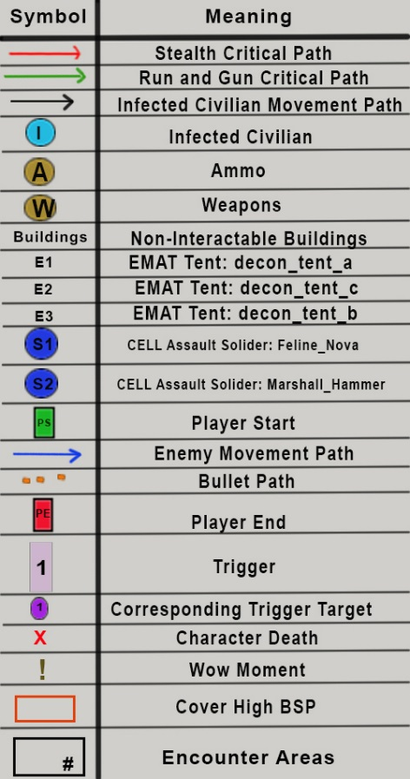
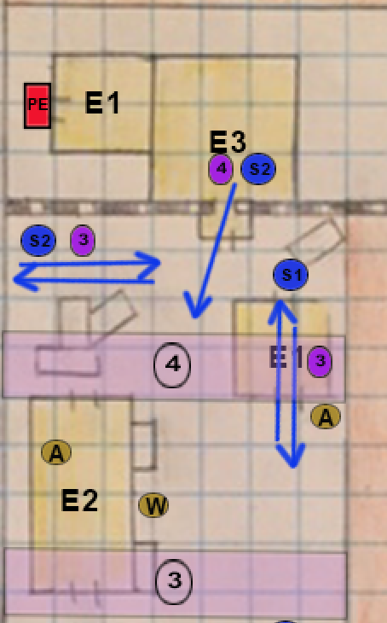
Figure 6: Encounter Area 2 Overview Map and Legend

Area Description
- After exiting Area 1, the player immediately steps into the third level trigger. This trigger activates two C.E.L.L. soldiers, one of type Feline and the other of type Marshall. Consequently, the player encounters a secondary enemy type in this area.
- The player’s Nano suit updates the player’s tactical options for the area.
- Regardless of the player’s preferred tactical option, the player approaches the depicted E3 decontamination tent. As they approach, they subsequently enter the fourth and final trigger of the level. This trigger activates a Marshall wielding C.E.L.L. soldier, causing him to move from his initial hiding position within the E3 tent.
- After avoiding or disposing of the three C.E.L.L. soldiers in this area, the player enters the E3 tent. Once inside, the player may explore the interior.
- To conclude the mission, the player proceeds through the tent and enters the connecting E1 tent.

Requirements
- Player must enter the final E1 decontamination tent to conclude the “Indiscriminate” mission.

Detailed Pathing Maps

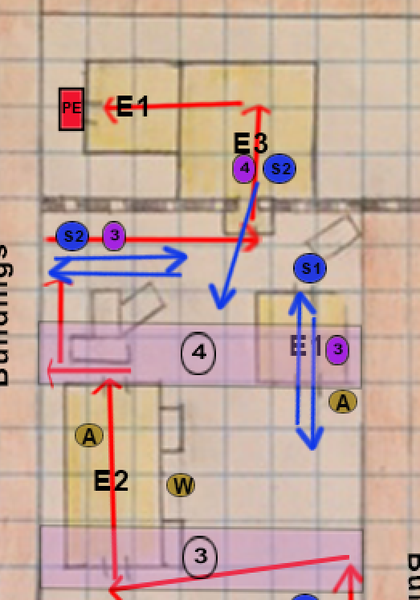
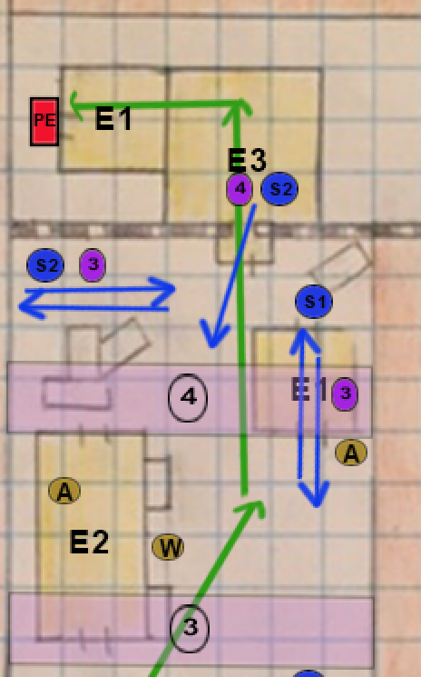

Figure 7: Area 2, "Run and Gun" Critical Path
Figure 8: Area 2, "Stealth" Critical Path

Path Descriptions
- Figure 7 details the player’s critical or optimal path when utilizing the “Run and Gun” tactic. In this depiction, the player charges forward, kills the second S2 soldier, and proceeds to the Player Exit.

- Figure 8 details the player’s critical or optimal path when utilizing the “Stealth” tactic. In this depiction, the player quietly moves through the nearby E2 tent, collecting ammo if necessary. Subsequently, the player briefly pauses behind a gathering of cars. As the closest S2 soldier moves along his designated path, the player can proceed to cloak and stealth kill the soldier. Quickly cloaking again, the player can easily avoid the remaining S2 soldier and enter the E3 tent. Once inside, the player can easily enter the E1 tent and thereby complete the mission.

Area 1

Special Thematic Elements
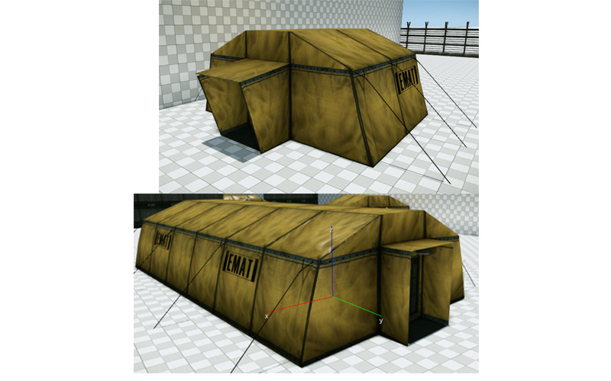

Figure 14: Area 1 E1 and E2 EMAT decontamination tents
“Indiscriminate” occurs within the confines of a military operated decontamination facility. Consequently, Area 1 frequently incorporates the E1 and E2 tents depicted in Figure 14. Contextually, these EMAT tents serve as refugee stations for those civilians uprooted by the “Manhattan” virus outbreak. Therefore, mattresses, food, and drinks litter the interiors and surrounding exteriors. However, despite the environment’s safety themed ambience, the player discovers blood, warning graffiti, and no signs of the inhabitants.

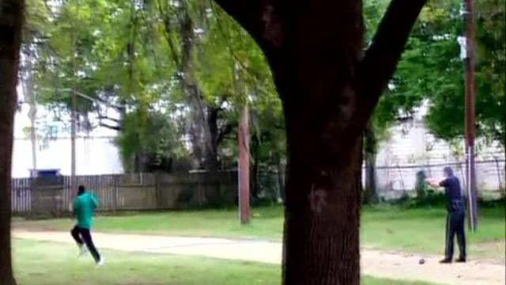





Figure 16: Real World Example of Scripted Civilian/CELL WOW Moment

http://wciv.images.worldnow.com/images/7399583_G.jpg
http://www.usnews.com/cmsmedia/22/51/c6984ebb447b90ba64f23bb5f404/150408-scott-embed1-editorial.jpg

Figures 16 provides perspective and reference for the WOW moment detailed in the “Area 1 Description” section. From behind an obstacle, the player witnesses an unarmed civilian fleeing from a C.E.L.L. soldier. When triggered, the officer fires and kills the individual. After the murder, the soldier moves toward the body and inspects his work.

Lighting/Mood

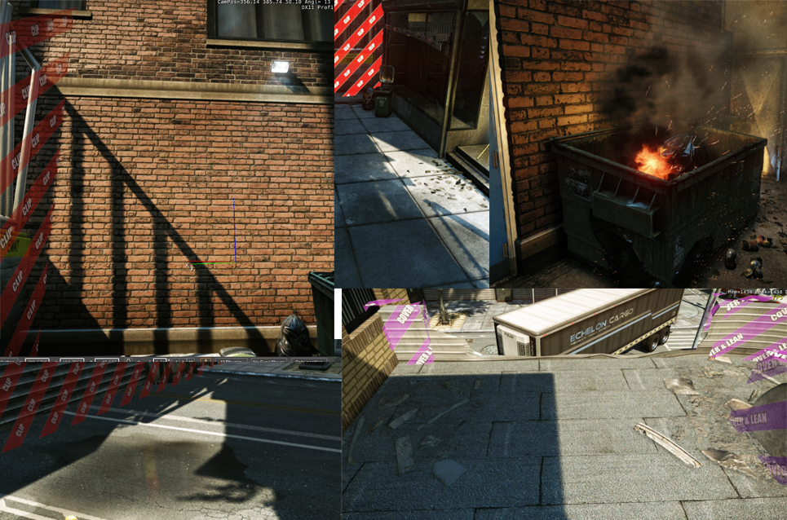
Figure 17: Examples of Exterior Lighting, Contrast, and Shadowing
Due to the level’s late afternoon setting, the exterior portions contain heavy shadowing and contrast. Long shadows and slightly darkening ambient characterize the first area and part of the second area’s outside sections. Furthermore, various other lighting or particle effects, such as the fire shown in Figure 17, provide a warm, unsettling orange glow.

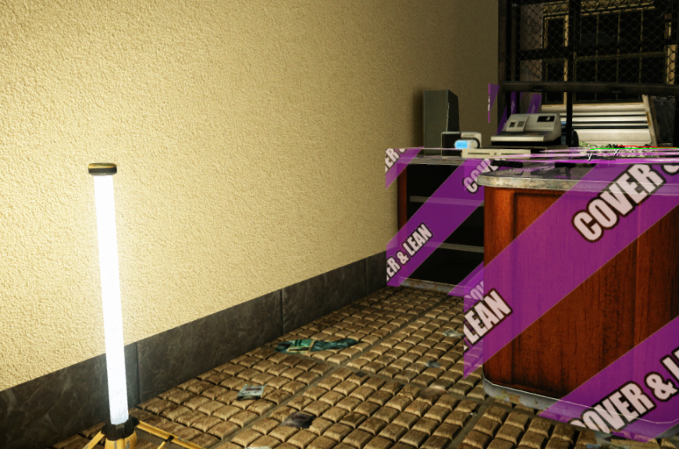
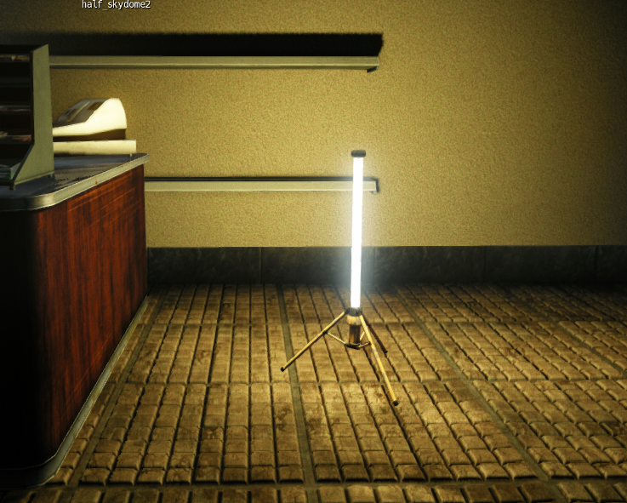

Figure 18: Examples of E1 and E2 Tent Interior Lighting

Figure 18 conveys the intended interior lighting of the E1 and E2 decontamination tents. Each of the artificial light sources appear to serve the C.E.L.L. soldiers and quarantined citizens living within the compound. However, their artificial, unnatural presence and unsettling hue hint at the negative practices held in this facility. Additionally, the light source provides many opportunities for the utilization of shadowing and contrast.

Visual References

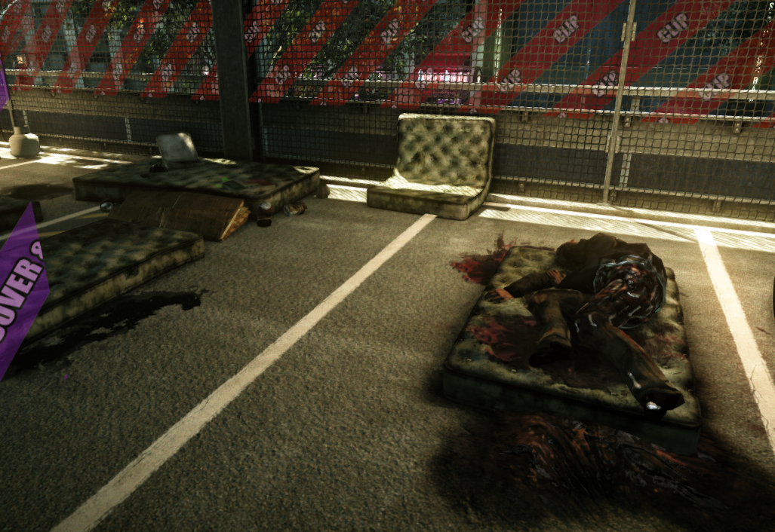

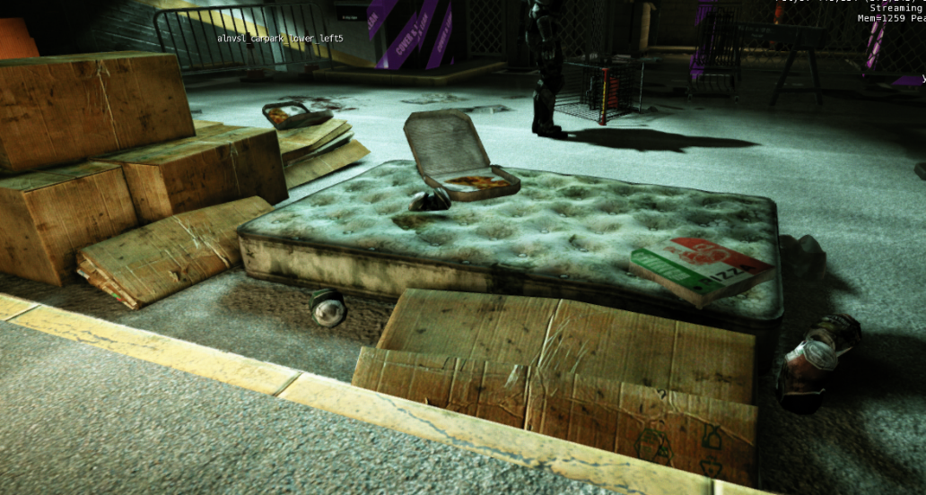

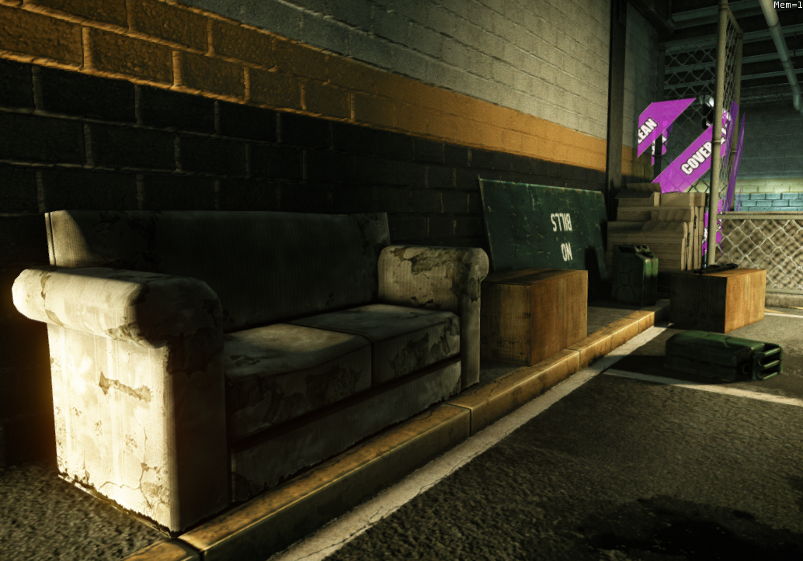

Figure 19: Example of Homeless Communities, Personal Items

Figure 19 provides Crysis 2 reference images of homeless-style communities. These minor level sections cause player intrigue, subsequently developing and conveying the mission’s backstory. The inhabitants confined within the “Indiscriminate” level’s compound similarly formed these areas in hopes of comfort and normalcy.

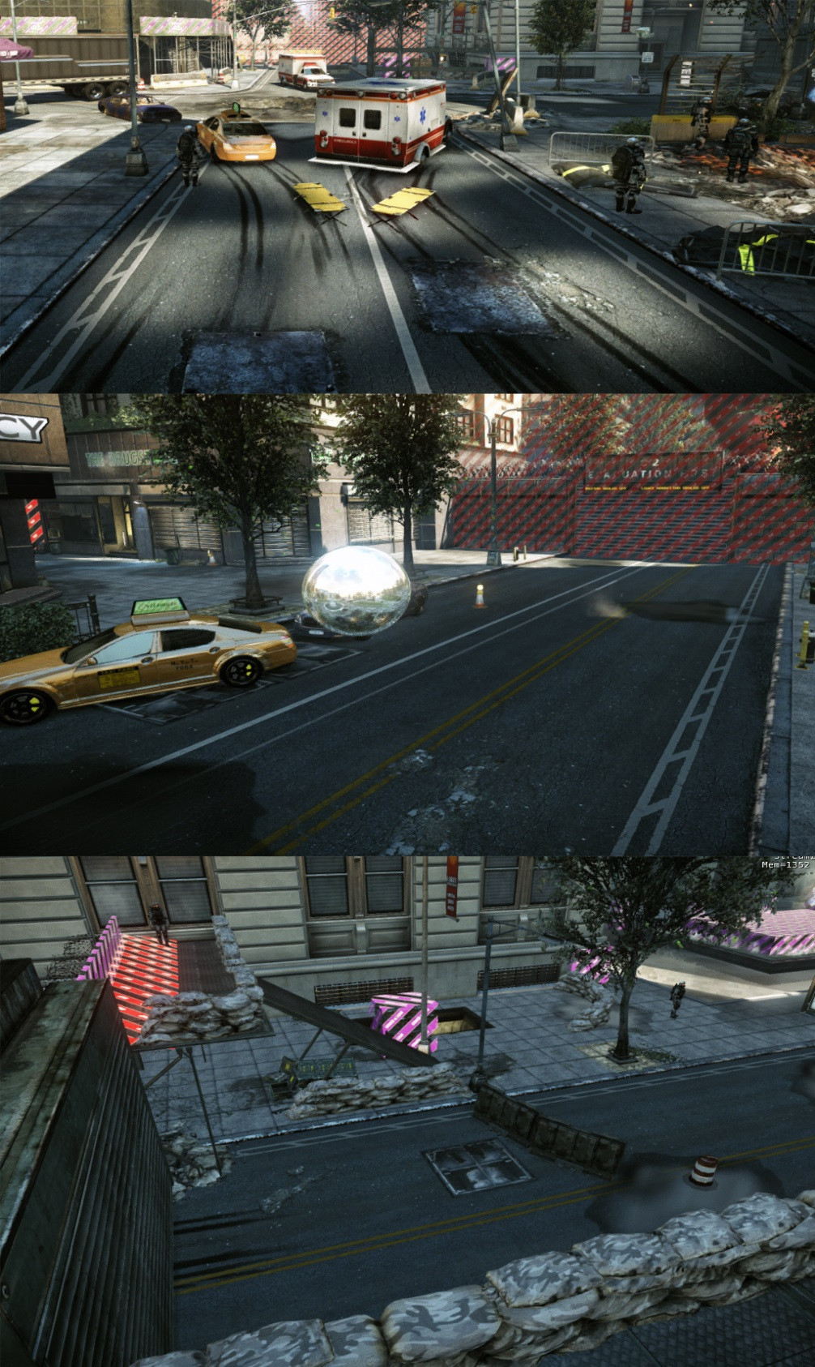

Figure 20: Example of "Indiscriminate's" Exterior Environment, Primarily found in Area 1

Figure 20 illuminates Area 1’s exterior environment. The C.E.L.L. have established gates to ward off unwanted invasions. Tents line the wide streets or open parking areas, forming mini groups. Exterior clutter, blood splatter, and graffiti populate the surrounding areas.

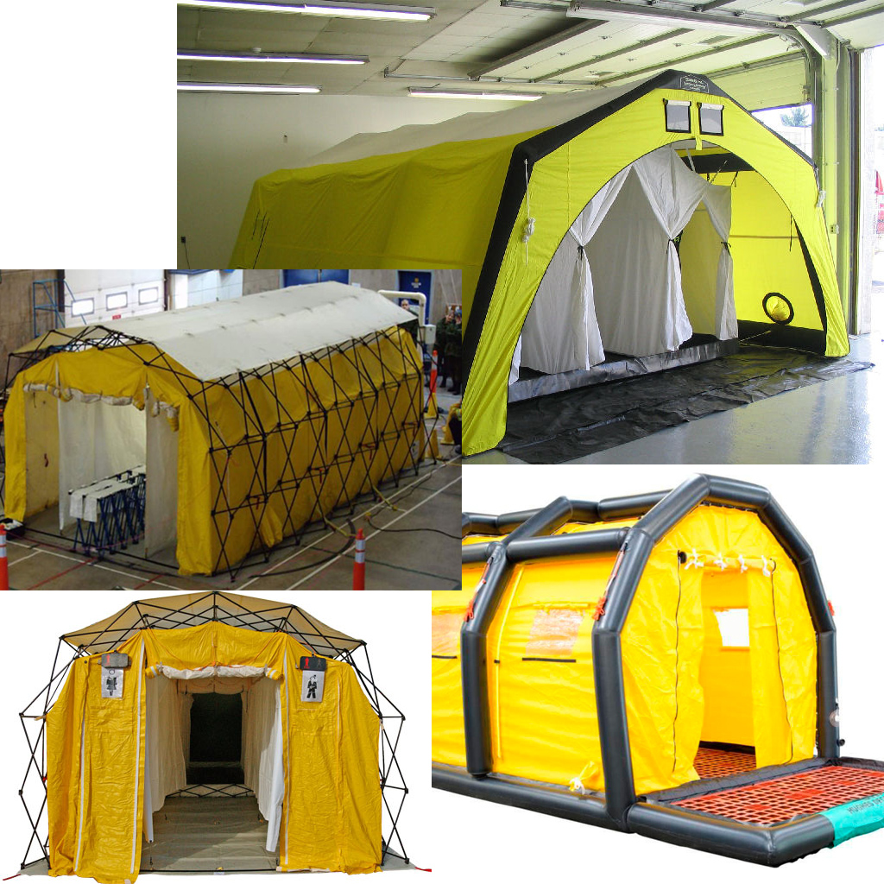
Figure 21: Real World Examples of Area 1 E1 and E2 tents
http://www.northumberland.gov.uk/images/fire-decontamination-tent.jpg
http://img.directindustry.com/images_di/photo-g/decontamination-shower-inflatable-15889-5130079.jpg
http://i.dailymail.co.uk/i/pix/2013/01/09/article-2259366-16D47F52000005DC-896_634x409.jpg
http://www.mchmrt.com/images/equipment/zumro.jpg

Area 2

Special Thematic Elements

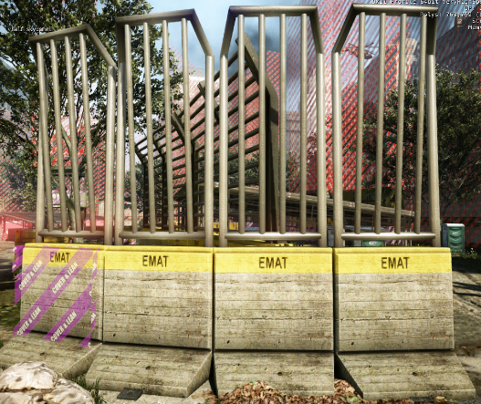
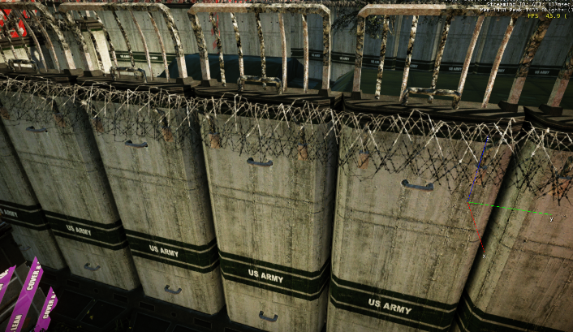
Figure 22: Example of Area 2’s Fencing/Barrier

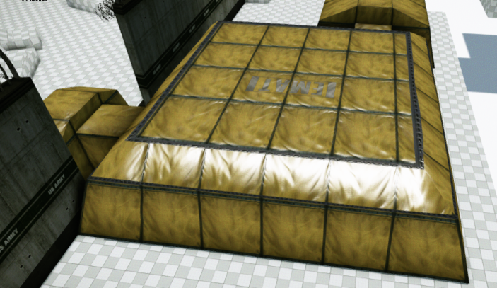
Figure 23: Example of unique Area 2 E3 Tent Mesh
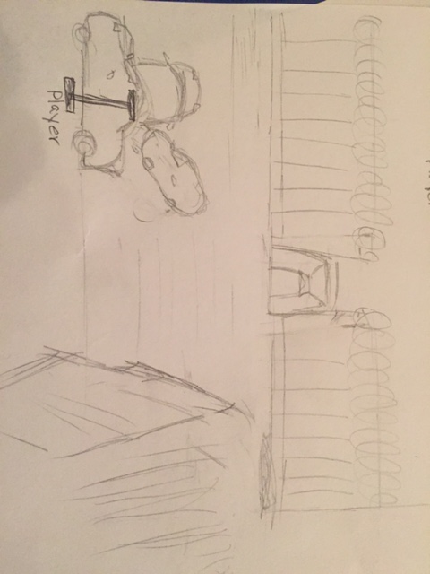
Figure 24: Perspective of Area 2 Scripted Enemy Encounters

Lighting/Mood

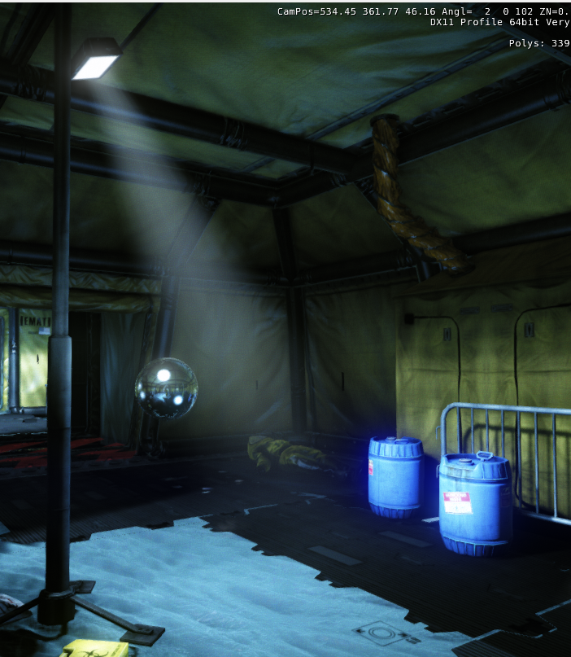

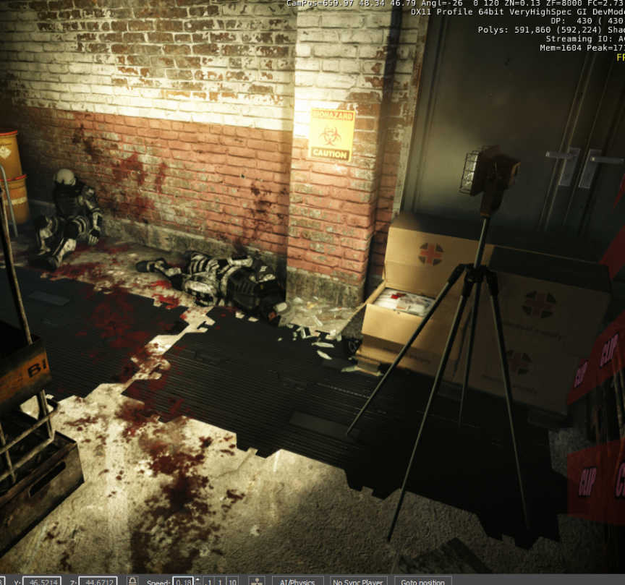
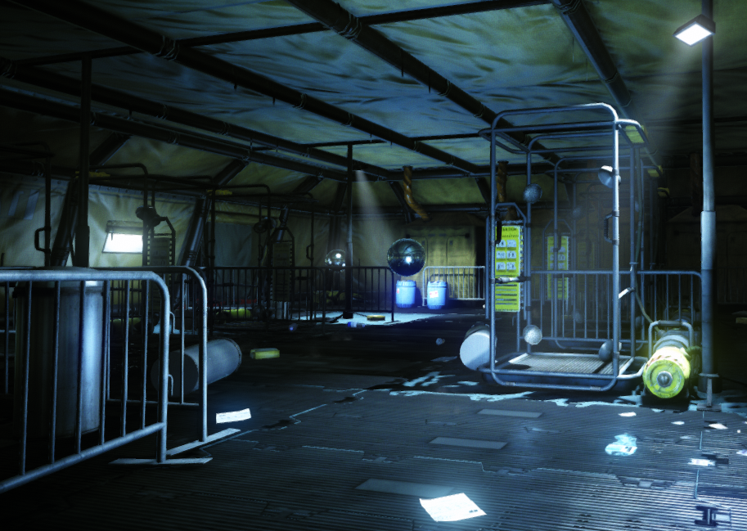

Figure 25: Overhead, artificial lights

In Figure 25, the overhead, stationed lights cast an odd glow on the otherwise dim area. This artificiality provides little comfort for the player and alludes to the ruthlessness behind the EMAT tents’ existence. Furthermore, the spotlight effect allows the designer to highlight key storytelling areas such as those filled with bodies, blood, or clutter.

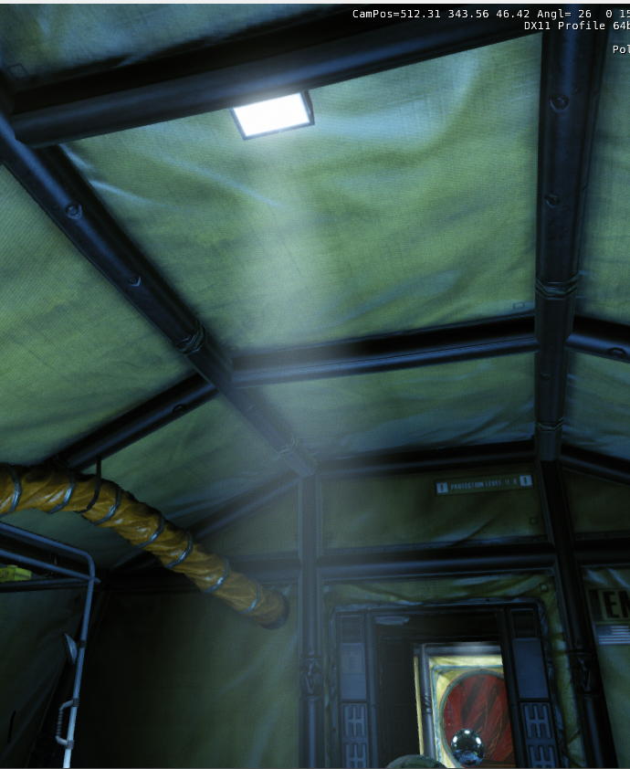
Figure 27: E3 Interior Tent Window Lighting

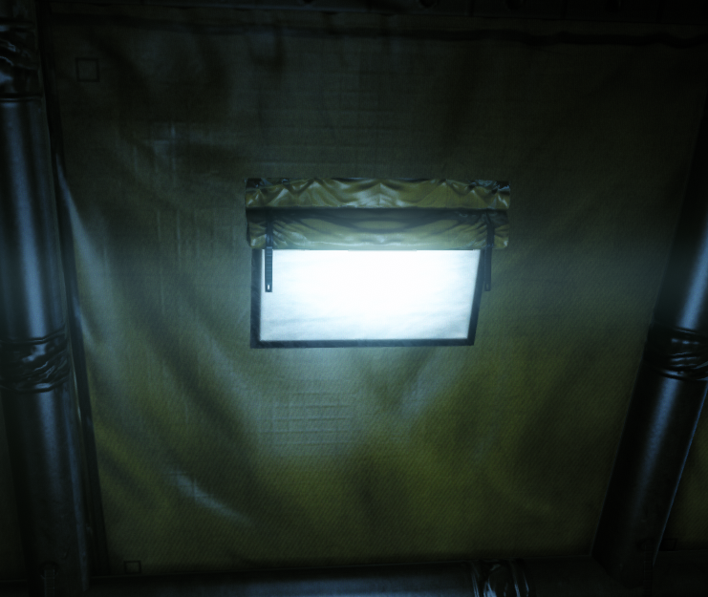

The E3 tent provides several variations of windows for which light to pour through. Figure 27 conveys these window examples, subsequently illustrating the strange emotional reaction they evoke. Light within an enclosed space of this nature seems ill fitting, dim, and ineffective. Therefore, the windows’ beams do little more than serve as eerie spotlights and highlights.

Visual References

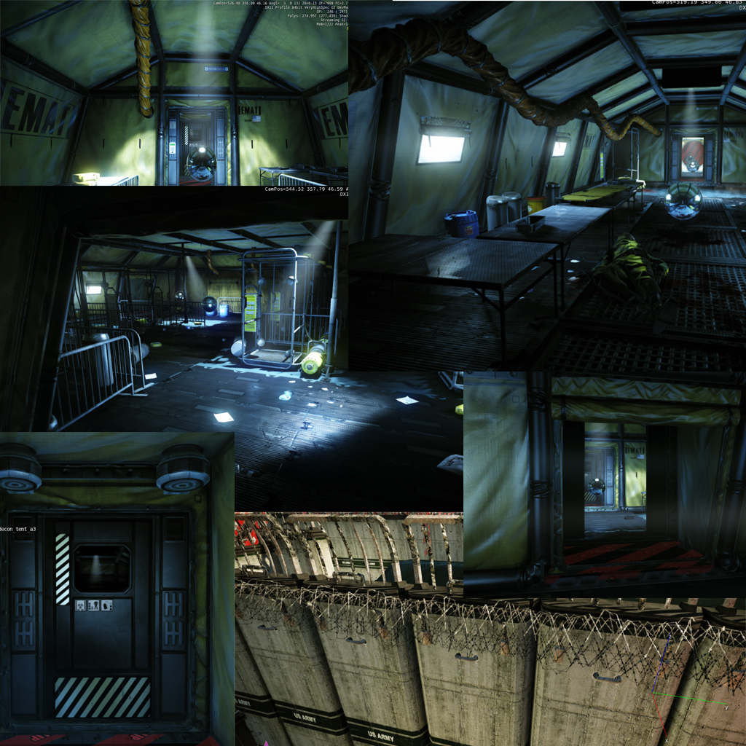
Figure 28: Examples of Area 2's pre-existing Crysis Visual References
Figure 28 conveys the dark, gloomy interior of the main E3 decontamination tent. The unsettling dark light, shining spotlights, and bleak shadows unsettle the player. Within this facility lies the core murderous C.E.L.L. practices, therefore hints of these deeds exist, scattered around the room.

Gameplay References
Much of the gameplay inspiration for this level stemmed from Telltale’s The Walking Dead video game. Throughout the experience, the environmental clutter and character interactions bolster the player’s intrigue. Blood splatter, sound cues, and item placement serve to guide the player to various conclusions and subsequent actions.
Additionally, the idea of killing the “infected” coincides with “Indiscriminate’s” own sub-plot. In fact, many zombie themed movies and games deal with the idea of killing based on fear or panic. These various scenes in The Walking Dead inspired the scripted event within “Indiscriminate”. Due to potential infection, characters witness a senseless murder, raising the question of humanity’s morality in times of crisis.
Another gameplay inspiration and thematic influence arises from various holocaust themed movies. The idea of persecution and extermination of a massive group of people originates from this horrific incident. Many times guards within these camps enjoyed the torture, hunt, and victimization of the Jewish hostages. “Indiscriminate” parallels the feeling of one powerful group torturing an innocent body of individuals.

