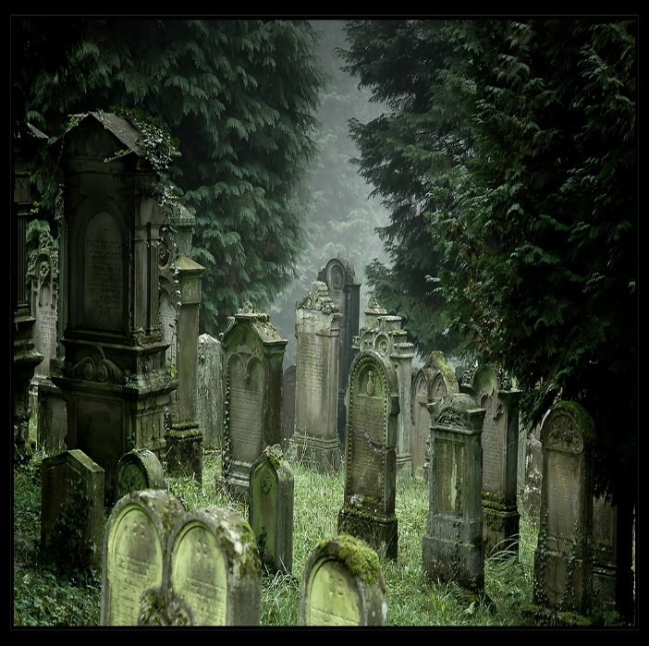

<http://fc08.deviantart.net/fs22/f/2008/031/f/3/Jewish_Graveyard_III_by_FrederikM.jpg>

Level Abstract:

The Mystery of Morawood

Elder Scrolls: Skyrim- Katie Wood

Version 1.0

|  |  |
| --- | --- |
| Designer: | Katie Wood |
| Document Date: | 11/11/14 |
| Intended Level Delivery Date: | 12/16/14 |

**Document Revisions Table**

|  |  |  |  |
| --- | --- | --- | --- |
| **Version** | **Description** | **Requestor** | **Date** |
| 0.1 | Initial Document | Professor Ouellette | 11/6/14 |
| 0.2 | Completed pages 1 and 2, Incorporated Key Theme References | Professor Ouellette | 11/9/14 |
| 1.0 | Finished Overview Map and Level Progression Chart, Completed remaining sections, Finished Level Abstract | Professor Ouellette | 11/10/14 |
|  |  |  |  |
|  |  |  |  |
|  |  |  |  |
|  |  |  |  |
|  |  |  |  |
|  |  |  |  |
|  |  |  |  |
|  |  |  |  |
|  |  |  |  |
|  |  |  |  |
|  |  |  |  |
|  |  |  |  |
|  |  |  |  |
|  |  |  |  |
|  |  |  |  |
|  |  |  |  |
|  |  |  |  |
|  |  |  |  |
|  |  |  |  |
|  |  |  |  |

# Table of Contents

Table of Contents 3

Table of Figures 4

Quick Summary 5

Hook(s) 5

Gameplay Highlights 5

Setting Summary 6

Mission Difficulty 6

Mission Metrics 7

Characters 7

Visual Themes 9

Key Theme References 10

Level Summary 14

Campaign 14

Context 14

Backstory 14

Aftermath 14

Objective(s) 14

Overview Map 16

Level Flow 17

Flow Summary 17

Level Progression Chart 21

Quest Descriptions 22

Main Quest 22

Side Quest 23

References 24

# Table of Figures

Figure 1: Gothic Dungeon Example 1, 10

Figure 2: Gothic Dungeon Example 2, 10

Figure 3: Gothic Dungeon Example 3, 11

Figure 4: Gothic Dungeon Example 4, 11

Figure 5: Eerie, Dark Village Example 1, 12

Figure 6: Dark Village Example 2, 12

Figure 7: Dark Village Example 3, 13

Figure 8: Dark Village Example 4, 13

Figure 9: Overview Map with Legend 16

Figure 10: Level Flow Image 0 17

Figure 11: Level Flow Image 1 17

Figure 12: Level Flow Image 2 17

Figure 13: Level Flow Image 3 18

Figure 14: Level Flow Image 4 18

Figure 15: Level Flow Image 5 18

Figure 16: Level Flow Image 6 19

Figure 17: Level Flow Image 7 19

Figure 18: Level Flow Image 8 19

Figure 19: Level Flow Image 9 20

Figure 20: Level Flow Image 10 20

Figure 21: Level Flow Image 11 20

Figure 22: Level Progression Chart Including Side Quest 21

Level Abstract

# Quick Summary

Set in the *Elder Scrolls: Skyrim* universe, “The Mystery of Morawood” quest incorporates the Nordic-inspired atmosphere and fantasy overtones inherent to the *Elder Scrolls* franchise. However, this single-player journey uniquely emphasizes mystery-based themes and gameplay mechanics. Due to this stylistic choice, the quest relies on exposition to build suspense and drive the plot. Nevertheless, the quest also employs classic role-playing combat and weapon collection. In addition to this main adventure, “The Mystery of Morawood” contains one optional side quest dubbed “Sweet Dreams.”

“The Mystery of Morawood” initializes when the protagonist, a wandering adventurer of unknown origin, reaches the Riverwood settlement. As the player strolls along the dampened riverbanks, they stumble across a fellow traveler’s campsite. Exhausted and distraught, the owner of the encampment reveals the mysterious woes befallen Morawood, his hometown. Since the dawn of the settlement’s formation, several Morawood children have vanished. Frustrated and suspicious, the traveler begs the protagonist to return with him to the village and investigate. Upon arriving at Morawood, the protagonist speaks to various characters, learning information through whispered rumors and gossip. As the protagonist pieces together the incriminating evidence, the “Mystery of Morawood” leads to a hellish dungeon, a wretched hagraven, and a depressing conclusion.

## Hook(s)

Bolstered by its perplexing mystery genre, the “Mystery of Morawood” inherently entices participants to realize the quest’s conclusion. Each conversation, discovery, and clue snags the player’s curiosity. As the player progresses, they develop an overarching need to locate the recently missing child’s whereabouts, discover the meaning behind Morawood’s unfortunate happenings, and expose the potential perpetrator.

Additionally, “The Mystery of Morawood” quest contains another highly potent hook. Upon discovering the identity of the antagonist, the player quickly ventures to this individual’s residence. With key in hand, the player unlocks the villain’s locked chamber and spots an oddly located trapdoor. Venturing inside this doorway, the player confirms their previous suspicions. Buried underneath the antagonist’s homestead lies a cavernous, cage-filled dungeon. Startled by this sudden shift in tone, the player’s inquisitiveness reignites. The mysterious change prompts the player to hurriedly venture forth and discern the new situation.

## Gameplay Highlights

The bulk of the “Mystery of Morawood’s” gameplay involves investigation and exposition. At the quest-giver’s request, the player scours local homesteads, collects incriminating evidence, and interviews the Morawood residents. This style of gameplay appears more heavily toward the quest’s beginning and middle portions.

The quest’s middle section introduces the first combat-based encounters. At a local woman’s insistence, the player ventures into the woods to recover a small doll. Upon nearing the location of the toy, wild wolves mercilessly attack.

During this period, the player may also optionally undertake the “Sweet Dreams” side quest provided by a local Morawood man. If the player accepts this expedition, the protagonist discovers and subsequently learns the Pacify spell. This Illusion incantation calms level twenty or below creatures and people, preventing them from engaging in battle for sixty seconds [1]. Interestingly, the player learns that the antagonist was utilizing this technique to lull the child victims into a stupor, making them easy targets.

After the player enters the antagonist’s cavernous lair toward the end of the quest, the player shifts from a brains-based to a brawn-based emphasis. As the player makes their way through the dungeon, skeleton warriors arise to attack the unsuspecting protagonist. Additionally, flesh-eating Skeevers scurry along the passageways, waiting to scavenge the meat from the skeletons’ conquest.

Nevertheless, the greatest gameplay highlight occurs when the player reaches the largest underground chamber. Upon entering the room, the human antagonist transforms into a ghastly hagraven. Consequently, the player must defeat the powerful witch and save Morawood.

## Setting Summary

|  |  |
| --- | --- |
| **Theme** | Nordic, Fantasy, Mystery, Horror |
| **Mood** | Eerie, Suspenseful, Gloomy, Creepy |
| **Setting** | Ancient Viking Era: Skyrim Fourth Century  1. Morawood village (Exterior)  *Bordered by forest and mountains.  2. Cavernous dungeon (Interior)  *Trapdoor entryway located inside of Zaida’s residence. Exit is near the graveyard.  3. Graveyard with various headstones  *Located near Morawood village (Exterior) |
| **Time of Day** | Nighttime |
| **Season** | Late fall, early winter |
| **Weather** | Preferably no precipitation but light rain acceptable |

## Mission Difficulty

|  |  |  |
| --- | --- | --- |
| Position | Difficulty | Reasons |
| Beginning  (Arriving at Morawood) | 2-3 | The initial portion of the “Mystery of Morawood” quest is significantly less challenging than the later sections. From the outset, the player does not face much of a physical challenge. Instead, Sven, the main quest giver, encourages the player to investigate through discussion and exploration. This task may still prove difficult to the player but the potential challenge stems from confusion or disorientation rather than a lack of skill. |
| Middle  (Traveling to the forest) | 5 | The middle section of the “Mystery of Morawood” quest proves slightly more challenging than the previous portion. Upon speaking to a local Morawood woman named Elsa, the protagonist subsequently ventures to a nearby wooded area. While searching the landscape, a pack of wolves violently confronts the player. This battle provides a taxing and stimulating experience as well as a deviation from the investigative gameplay. |
| End  (Entering and exiting the interior) | 7-8 | In the final segment of the “Mystery of Morawood” quest, the protagonist encounters their greatest challenge thus far. Two new enemies, namely skeletal warriors and slimy Skeevers, inhabit the dank, underground cavern. These creatures prove more daunting opponents than the wolves from the quest’s middle section. However, the most prominent reason for the increased difficulty is due to a violent confrontation with the antagonist. Upon entering the largest chamber in the dungeon, the villain transforms into a wicked hagraven. This beast’s incredible strength and magical ability is well renowned in Skyrim lore [2]. |

Scale: 1-10 (1 is Easiest and 10 is Hardest)

## Mission Metrics

|  |  |
| --- | --- |
| **Play Time** | 10-15 minutes depending on player expertise |
| **Critical Path** | ~3,290 Ft. |
| **Physical Area** | Exterior: 4 x 6 cells; 768 X 1152ft *One cell at 192ft.  Interior: (Maximum Height X Width)  15X 20 blocks;  One block at 256 pixels X 256 pixels = 3840 pixels X 5120 pixels  One block at ~10Ft. X 10Ft. = ~150Ft. X 200 Ft. |

### Characters

|  |  |
| --- | --- |
| Character | Description |
| Player | Protagonist: After a stroll along the banks of Riverwood, the player encounters Sven, a concerned traveler, at a nearby campsite. Sven relays his tale of Morawood’s mysterious child disappearances and enlists the player’s assistance with promise of reward. Intrigued, the player accepts and travels to the isolated settlement with Sven. Upon arriving, the player speaks with the various Morawood residents, subsequently learning more of the mysterious happenings. With the collection of several “clues,” the player travels to Zaida’s homestead and discovers a hidden trapdoor. This passageway leads to a gothic, dungeon-like chamber. Traversing the weaving corridors, the player battles through skeletal warriors and scurrying skeevers. In the final cavern, the player encounters Zaida, the first mother to lose a child to the disappearances. With the woman’s sudden hagraven transformation, the player must fight the villain and notify Sven of their discovery. |
| Zaida | Antagonist: Morawood’s local apothecary. After her husband cruelly abandons his family for a younger lover, Zaida develops a quiet, passive temperament. Unfortunately, not long after this occurrence, her only child, Frederick, also unexpectedly vanishes. Since his disappearance, several other Morawood children have mysteriously gone missing. Upon the protagonist’s investigation, Zaida’s true manipulative and evil nature arises. She is responsible for the kidnapping and sacrificing of the missing Morawood children. Selfishly, Zaida longed to retain her youthful appearance and subsequently win back her cheating husband’s heart. However, this sacrificial magic wears away every few years, causing the once beautiful Zaida to deteriorate into a hagraven. Toward the end portion of the “Mystery of Morawood” quest, Zaida voluntarily assumes the hagraven identity in order to silence the player forever. |
| Frederick (Child) | NPC: The son of Zaida. Due to his deserting father, Frederick develops a depressive personality. Consequently, the boy isolates himself from the other children, hiding away inside of his homestead. Soon after the beginning of this hermit-like behavior, Frederick mysteriously disappears. His departure signals the first of many subsequent Morawood abductions. Despite the villager’s efforts, Frederick is never located and lives on in memory only. |
| Sven | NPC (Major Quest Giver): Traveling Morawood resident. Fed up with the disappearances in his hometown, Sven traverses Skyrim in search of assistance and answers. Upon meeting the protagonist, Sven expresses his suspicion of the other villagers and begs for the player’s unbiased help. If the player agrees to the task, Sven guides the protagonist to Morawood. Upon arriving, this quest giver instructs the player to investigate by speaking with settlers and searching households. |
| Elsa | NPC (Sub-Quest Giver): Mother of Anna. With the recent disappearance of the Morawood child Olaf, Elsa is understandably concerned for the welfare of her daughter, Anna. When the player speaks to Elsa, she gives them a mandatory sub-quest involving the acquisition of her daughter’s lost doll. By returning this toy to Anna, the player acquires a key unlocking Zaida’s secret room. |
| Anna (Child) | NPC (Item Giver): Daughter of Elsa. While playing with her friend Olaf in the woods, the boy suddenly vanishes. Distraught over this loss and fearing for her own safety, Anna subsequently becomes a mute. Upon Elsa’s prompting, the player fetches Anna’s favorite toy, which she hastily dropped after discovering Olaf’s abduction. Reunited with the item, Anna finally develops the courage to speak and rewards the player with the key to Zaida’s hidden room. |
| Olaf (Child) | NPC: The son of Joleiv. While playing with Anna in the woods, Olaf mysteriously vanishes. As the most recent victim, the settlers hurriedly search for his whereabouts. The boy’s disappearance motivates Sven to leave Morawood and enlist outside assistance. Unfortunately, the child is already deceased by the time the player discovers Zaida’s hideout. |
| Joleiv | NPC (Item Giver): Father of Olaf. Distraught at the loss of his child, Joleiv is very willing to assist the player in any facet. After the protagonist speaks with him, Joleiv relinquishes Olaf’s tattered journal. Inside the pages of this personal book, Olaf hints at the presence of a trapdoor within Zaida’s household. |
| Alvis | NPC (Side Quest Giver): Resident of Morawood. Concerned for the welfare his fellow villagers, Alvis asks the player to investigate the cemetery for any potential clues. Upon reaching the indicated location, the player discovers bloodstains and clothing items. After reporting these findings to Alvis, the Morawood man gives the player an Illusion spell book. The tome contains the Pacify spell, which temporarily calms aggressive creatures and humans. Alvis claims to have discovered this magical text around the area he asked the player to explore and was therefore highly suspicious. |
| Harold | NPC: Resident of Morawood. Harold is unconnected to the mysterious village happenings. However, he finds the horrific Morawood occurrences repulsive and vile. His belief in the occult and mystical leads him to propose that the vanishings stem from a magical creature of some kind. |

## Visual Themes

|  |  |
| --- | --- |
| Theme | Description |
| Creepy, Haunting, Mysterious, Dangerous Dungeon/Lair  (Interior) | Beneath the floor of Zaida’s residence, exists a secret cavernous dungeon. Carved by her own magical power, the rock passageway’s rough walls are jagged and scuffed. The apothecary’s illegal and horrific practices radiate in the form of blood, bodies, and scattered possessions. Along the walls of the cavern reside cages, used to confine those who vanished from Morawood years prior. Some of the skeletal remains of these victims rise up and assume the role of warrior. In addition, Skeevers scamper along the passageways, nibbling on any leftover piles of flesh. Due to the various enemies, a nav mesh blankets the entirety of this hellish dwelling. Darkness envelops the area except for the occasional golden glow from a torch or lantern. Ambient lighting is quite dark and foreboding with an undertone of red, yellow, or orange coloring (See Figure 1). |
| Eerie, Dark, Spooky, Foreboding Village and Cemetery  (Exterior) | Surrounded by mountains and trees, the isolated town of Morawood quietly and peacefully survived. However, due to the child disappearances, the village adopted a horrific and unsettling atmosphere. The nighttime sky darkens all exterior sections. Yellow Lantern and light post beams serve as the solitary means of illumination. A nearby graveyard, filled with tombstones, further bolsters the creepy and otherworldly theme. Nav meshes exist throughout the village, woods, and cemetery to form the settlers and wolves’ walking paths. |

## Key Theme References

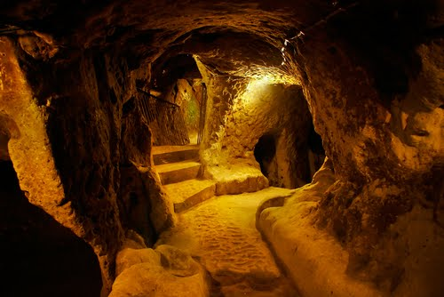

Figure : Gothic Dungeon Example 1,

Source-<http://2.bp.blogspot.com/_adQFJxToEyc/TCPsovPOlYI/AAAAAAAAAro/qLHgcrnvXoQ/s1600/derinkuyu-tr616.jpg>

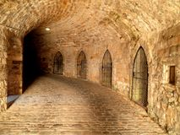

Figure : Gothic Dungeon Example 2,

Source-<http://thumbs.dreamstime.com/t/castle-underground-dungeon-prison-germany-39467918.jpg>

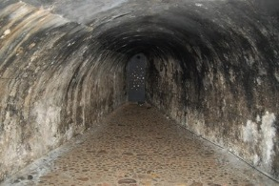

Figure : Gothic Dungeon Example 3,

Source-<http://photos.travellerspoint.com/155426/1smallKron..dungeon.jpg>

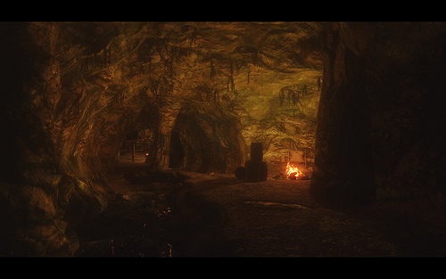

Figure : Gothic Dungeon Example 4,

Source-<https://c1.staticflickr.com/9/8037/7955596262_695f910dd6.jpg>

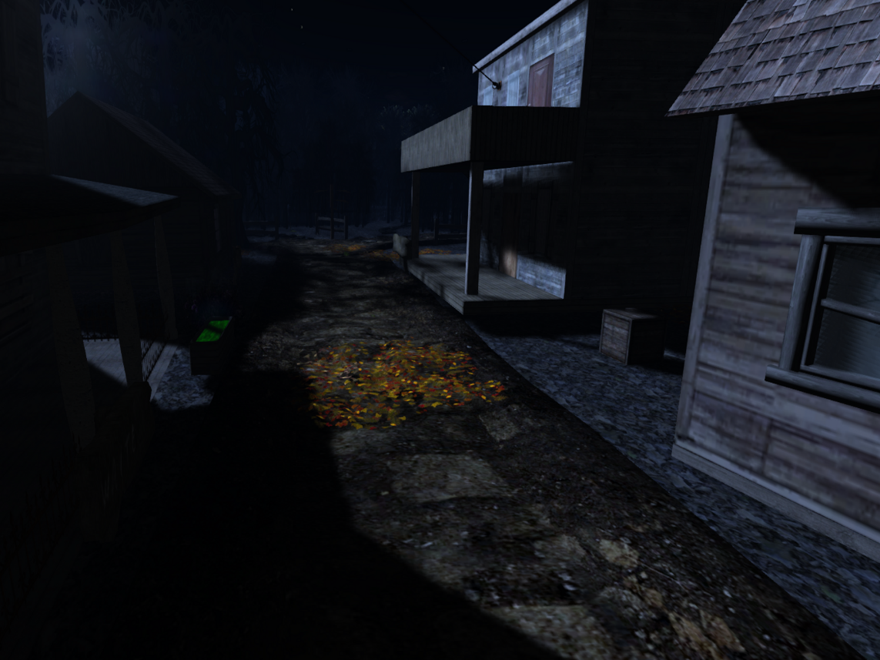

Figure : Eerie, Dark Village Example 1,

Source-<http://honourmcmillan.files.wordpress.com/2012/09/nyght-4.png>

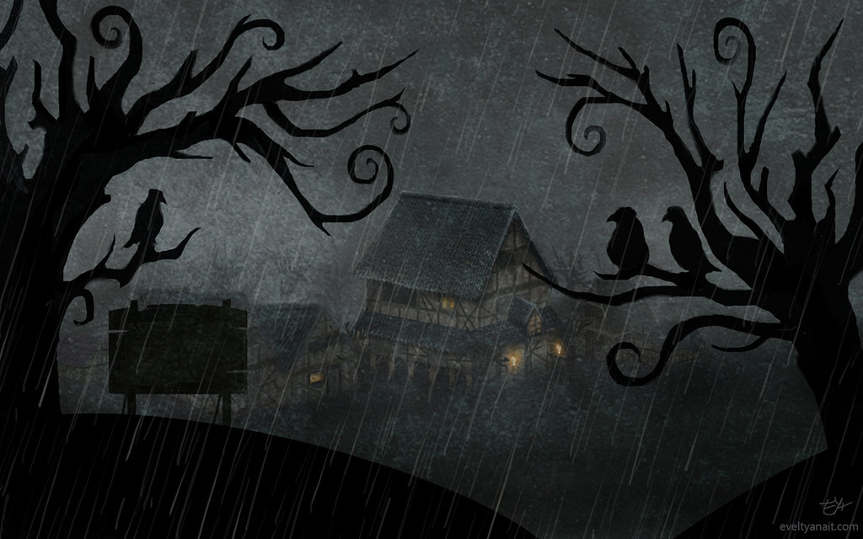

Figure : Dark Village Example 2,

Source-<http://fc02.deviantart.net/fs71/i/2013/204/a/c/creepy_town_by_evelt_yanait_by_evelt_yanait-d6es235.jpg>

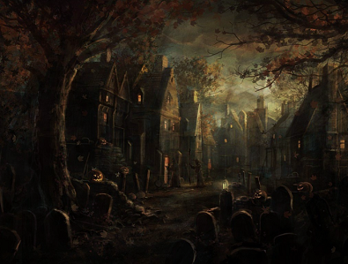

Figure : Dark Village Example 3,

Source-<http://i963.photobucket.com/albums/ae115/Guardian0Angel/scary_townnightsmall.png>

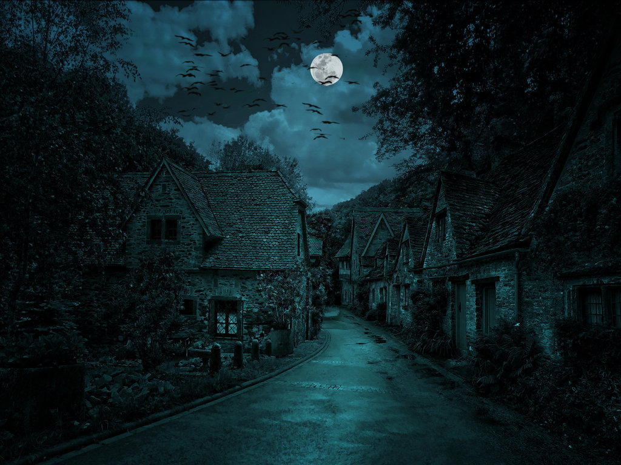

Figure : Dark Village Example 4,

Source-[http://fc04.deviantart.net/fs71/i/2013/257/8/2/the_dark_village_by_nacho3-d68dwrv.jpg](http://fc04.deviantart.net/fs71/i/2013/257/8/2/the_dark_village_by_nacho3-d68dwrv.jpg%20)

# Level Summary

## Campaign

### Context

Within the context of the Elder Scrolls: Skyrim game, “The Mystery of Morawood” is an independent, stand-alone quest. The completion of the main quest or other side quests is not necessary to begin and finish this unique, mystery-based challenge. However, “The Mystery of Morawood” itself, contains one optional side quest entitled “Sweet Dreams.” To locate this mission, players must traverse to Riverwood Bridge and talk with Sven, the traveling Morawood resident, at his nearby encampment.

### Backstory

The foundation of Morawood was a joyous occasion marked by the inhabitants’ celebratory cheers. For many years, this small settlement experienced peace and prosperity. However, one day this all changed. The villagers awoke to the screams of Zaida, the local apothecary. Alarmed, the Morawood men rushed to her dwelling. Upon entering, the concerned neighbors discovered Zaida collapsed on the floor, uncontrollably weeping. After several moments, the male villagers discovered the disappearance of her only son, Frederick. Immediately, the villagers conducted a search of the surrounding areas. Nevertheless, despite their efforts, the child seemingly vanished from thin air. Baffled, the villagers could do nothing but console Zaida through her pain. Years passed and several more children vanished without a trace. Spooked by Morawood’s suspicious atmosphere, local resident, Sven embarks on a journey across Skyrim in hopes of enlisting assistance.

### Aftermath

Upon defeating the hagraven version of Zaida, the protagonist exits her dungeon and unexpectedly appears within the graveyard. Consequently, the protagonist realizes that Zaida used this passageway to rid herself of the bodies in the most likely yet least suspicious location of all, the cemetery. Hastily, the player returns to Sven and relays their depressing discoveries. With “The Mystery of Morawood” quest completed, Sven gives the player the promised monetary reward. Relieved and grateful for the player’s assistance, the Morawood man thanks the player once more confiding he never suspected the apothecary of any transgressions. Despite the pain and sorrow felt for the missing children, the villagers attempt to rebuild their lives and move on from this experience. Subsequently, the protagonist departs Morawood in search of new adventure and conquest.

## Objective(s)

* Speak to Sven, the wandering Morawood traveler, near Riverwood Bridge.
* Accept Sven’s request to investigate the Morawood mystery.
* Travel to Morawood with Sven.
* Investigate the disappearance of Olaf, the most recent missing child.
* Speak to Zaida
* Speak to Joleiv
* Speak to Harold
* Speak to Elsa
  + Mandatory Sub Quest: Fetch Anna’s missing toy
    - Failure: Death by Wolves
  + Return to Anna and give her the toy
  + Receive key to Zaida’s secret room in return
* Enter Zadia’s House
* Unlock Zadia’s locked doorway
* Enter secret trapdoor hidden in the previously locked room
* Traverse the dungeon’s corridors
* Enter the first chamber
* Defeat the skeletal warriors and Skeevers present in the chamber
  + Failure: Death by skeletal warrior or Skeever
* Traverse the dungeon’s corridors
* Enter the second chamber
* Defeat the skeletal warriors and Skeevers present in the chamber
  + Failure: Death by skeletal warrior or Skeever
* Traverse the dungeon’s corridors
* Enter the final cavern chamber
* Confront Zaida about her crimes
* Defeat the transformed Zaida
  + Failure: Death by the hagraven version of Zaida
* Exit the dungeon
* Report discoveries to Sven
* Collect compensation for completing the “Mystery of Morawood” quest
* Leave the Morawood settlement

**Side Quest**

* Speak to Alvis
  + Side Quest: Search for suspicious activity near the cemetery.
  + Failure: Death by Wolves
  + Return to Alvis with news of bloodstains and abandoned clothing
  + Receive Pacify spell from Alvis as reward.

## Overview Map

One Cell = 192Ft. X 192Ft.

One Block

= 10 Ft. X 10Ft.

150Ft.

Figure : Overview Map with Legend

200Ft.

768 Ft.

Ft. Ft.

1152 Ft.

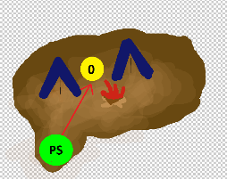

## Level Flow

### Flow Summary

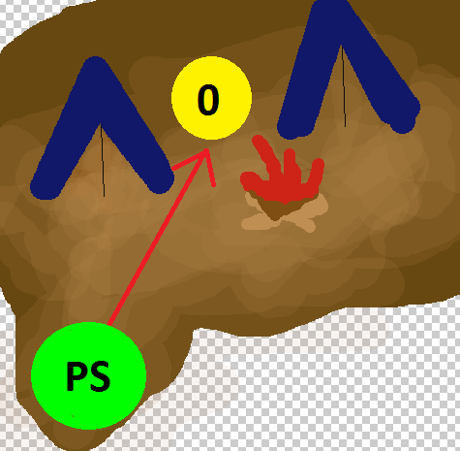

Figure : Level Flow Image 0

1. Player discovers Sven at his Riverwood campsite. After speaking with him, the protagonist accompanies Sven to his hometown of Morawood.



Figure : Level Flow Image 1

1. Upon reaching Morawood, the player begins interviewing Zaida, the first woman to have mysteriously lost a child.

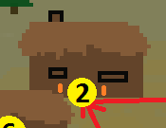

Figure : Level Flow Image 2

1. From Zaida’s homestead, the player travels to visit Joleiv, the father of the most recent victim. Grateful for the player’s assistance, Joleiv gives the player his son’s tattered journal.

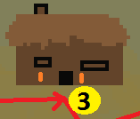

Figure : Level Flow Image 3

1. At Harold’s abode, the player learns that the Morawood incidents may have a supernatural undertone.

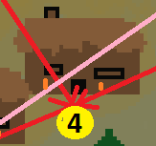

Figure : Level Flow Image 4

1. Player reaches Elsa and Anna’s home and subsequently engages in the mandatory sub-quest to retrieve Anna’s lost toy.

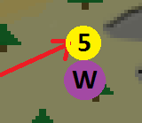

Figure : Level Flow Image 5

1. Upon discovering the doll’s location, the player encounters a pack of vicious wolves. The player then returns the doll to Anna and receives the key to Zaida’s secret room. (WOW moment)

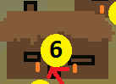 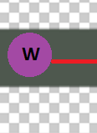

Figure : Level Flow Image 6

1. With the key in hand, the player goes to Zaida’s homestead to investigate. Upon entering the deserted house, the player unlocks the door and spots a trapdoor in the floor. Intrigued, the player opens the door and slips inside. Once inside the dungeon, the player realizes Zaida’s guilt (WOW Moment)

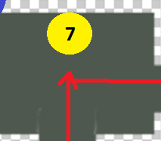

Figure : Level Flow Image 7

1. As the player ventures through the caverns, they encounter skeleton warriors and Skeevers looming in the larger chambers ahead.

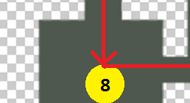

Figure : Level Flow Image 8

1. Player continues forward to the next chamber. Inside the second room resides several more skeletons and Skeevers waiting to attack.

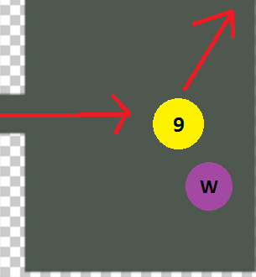

Figure : Level Flow Image 9

1. Player enters the main cavern chamber and discovers Zaida standing over Olaf’s dead body. Enraged at the player’s presence, she transforms into a hideous hagraven and launches an attack. (WOW Moment)

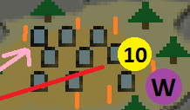

Figure : Level Flow Image 10

1. With Zaida defeated, the player exits the dungeon and emerges within the cemetery’s boundaries. Solemnly, the player realizes that Zaida utilized the chamber to kill her victims and subsequently dump their bodies in the graveyard. (WOW Moment)

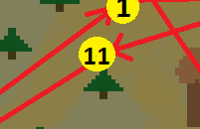

Figure : Level Flow Image 11

1. The player reports their newfound realizations to Sven, the original quest giver. Sven compensates the player for their efforts and the player subsequently leaves Morawood.

### Level Progression Chart

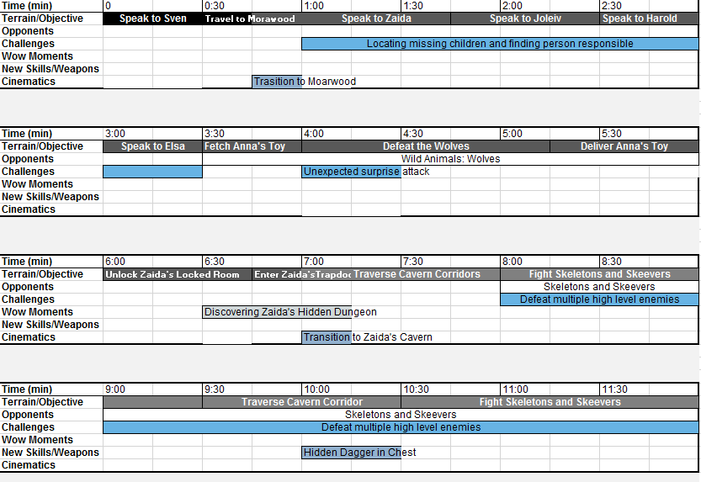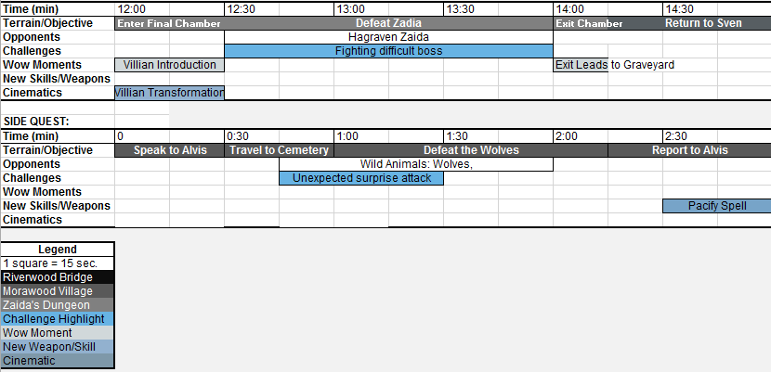

Figure : Level Progression Chart Including Side Quest

# Quest Descriptions

## Main Quest

1. Player confronted by Sven at a campsite near Riverwood Bridge. (exposition, main character)
2. Player receives information on “The Mystery of Morawood” quest from Sven. The protagonist must investigate the village’s mysterious child disappearances. (dramatic premise/situation, inciting incident)
3. Player travels to Morawood with Sven.
4. Sven prompts the player to speak to the villagers of Morawood. (inciting incident)
5. Player speaks to Zaida, the first parent to have a child vanish. (exposition, antagonist)
6. Player speaks to Joleiv, the father of the most recent missing child. The protagonist receives his missing child’s journal. (exposition, plot point)
7. Player speaks to Harold who whispers of supernatural occurrences. (exposition, plot point)
8. Player speaks to Elsa and subsequently receives a mandatory sub quest to find her daughter’s doll. (exposition, plot point)
9. Player searches for Anna’s doll and encounters vicious wolves. (obstacle, dramatic situation)
10. Player locates Anna’s toy and returns the item to the little girl. In return, the child gives the protagonist the key to Zaida’s secret room. (midpoint, exposition, dramatic situation, plot point)
11. Player ventures to Zaida’s homestead and enters the deserted household.
12. Player unlocks Zaida’s only locked room and subsequently enters.
13. Player discovers a trapdoor inset into the floor. (dramatic situation, plot point)
14. Player enters the trapdoor and finds themselves in Zaida’s underground dungeon. (dramatic situation, plot point)
15. Player proceeds down the winding corridors.
16. Player enters a small chamber and encounters skeleton warriors and Skeevers. (obstacle)
17. Player leaves the small chamber and proceeds down the winding corridors.
18. Player enters a second small chamber and encounters another horde of skeletal creatures and Skeevers. (obstacle)
19. Player exits the small chamber and proceeds down the winding corridors.
20. Player enters the final chamber and encounters Zaida. (obstacle)
21. Zaida confesses to her sacrificial practices and transforms into a hagraven. (exposition, climax)
22. Player battles the powerful bird-like creature. (obstacle, climax)
23. Player defeats Zaida with a fatal finishing attack. (first culmination, climax)
24. Player exits the cavern and emerges in the Morawood graveyard. (falling action)
25. Player travels to Sven’s location to relay their terrible findings. (falling action)
26. Player speaks to Sven, detailing Zaida’s betrayal. (falling action, denouement)
27. Player collects reward and departs from Morawood. (denouement)

## Side Quest

1. Player speaks to Alvis by his homestead in Morawood. (exposition, main character)
2. Player receives information regarding Alvis’ suspicions. They must travel to the Morawood cemetery and locate any irregular items or activity. (dramatic premise/situation)
3. Player ventures the forested area around the cemetery.
4. During their search, the player encounters and battles vicious wolves. (obstacle)
5. Player discovers bloodstains and abandoned clothing items in the location Alvis specified. (dramatic situation, exposition, plot point, climax)
6. Player returns to Alvis to report their discovery (falling action)
7. To repay the player for their deed, Alvis gives them the Pacify spell book. (exposition, denouement)

# References

[1] “Skyrim: Pacify (spell)." *Unofficial Elder Scrolls Pages*. 26 Mar. 2014. Web.

<<http://www.uesp.net/wiki/Skyrim:Pacify_(spell)>>.

[2] “Skyrim: Hagraven” Unofficial Elder Scrolls Pages. 2 Mar. 2014. Web.

<<http://www.uesp.net/wiki/Skyrim:Hagraven>>

*All figure references are included in the document above.